DATA SCIENCE TOOLBOX: PYTHON PROGRAMMING
PROJECT REPORT
(Project Semester January-April 2025)

Election Data Analysis: 2024 Lok Sabha Results using Python

Submitted by

Yashashvi Pal

Registration No.: 12313607

Programme and Section: BTech CSE in Data Science
KM005
Course Code: INT 375

Under the Guidance of

Maneet Kaur
15709
Discipline of CSE/IT

Lovely School of Computer Science and Engineering

Lovely Professional University, Phagwara

CERTIFICATE

This is to certify that Yashashvi Pal bearing Registration no. 12313607 has completed INT 375 project titled, “Election Data Analysis: 2024 Lok Sabha Results using Python” under my guidance and supervision. To the best of my knowledge, the present work is the result of her original development, effort and study.

Signature and Name of the Supervisor: Maneet Kaur
School of Computer Science and Engineering
Lovely Professional University
Phagwara, Punjab.

Date: 11-04-2025

DECLARATION

I, Yashashvi Pal, student of Data Science under CSE/IT Discipline at, Lovely Professional University, Punjab, hereby declare that all the information furnished in this project report is based on my own intensive work and is genuine.

Date: 11-04-2025 Signature :
Registration No. 12313607 Name of the student: Yashashvi Pal

ACKNOWLEDGEMENT

I would like to express my sincere gratitude to all those who supported and guided me throughout the completion of this project.
First and foremost, I would like to thank my faculty mentor, Ms. Maneet Kaur Ma’am, for her continuous support, valuable insights, and constructive feedback, which helped shape this project in the right direction.
I would also thank Lovely Professional University for providing the necessary resources and support.
I would also like to thank my family and friends for their encouragement and motivation during the entire process.
Lastly, I am grateful to have access to tools like Python, Pandas, and Seaborn, which made the data analysis and visualization journey smooth and insightful.

TABLE OF CONTENT

Introduction
Source of dataset
Dataset Preprocessing
EDA Process
Challenges Faced
Analysis on dataset (for each objective)
Specific Requirements
Analysis results
Visualization
Conclusion
Future scope
References

INTRODUCTION

Elections are one of the most critical pillars of democracy. The 2024 Lok Sabha elections in India witnessed active participation from various political parties and voters across the country. Analysing such a large dataset not only helps us understand voting patterns and political dynamics but also allows us to derive insights that can inform future strategies and decision-making.
This project involves data cleaning, preprocessing, visual analysis, and generation of insights from the official 2024 General Election dataset using Python libraries like Pandas, Matplotlib, and Seaborn.

SOURCE OF DATASET
The dataset used in this project is titled: "Comprehensive Results of General Election to Lok Sabha 2024"
It was published and made available by the Election Commission of India (ECI).
I found it on the site “dataful”
https://dataful.in/datasets/19985/

DATASET PREPROCESSING

Before beginning the analysis and visualization, the dataset underwent several preprocessing steps to ensure it was clean, consistent, and ready for exploration. Proper preprocessing is critical in any data science workflow, as it helps prevent inaccurate insights due to messy or incomplete data.

1. Loading the Dataset
The dataset used for this project is titled "Comprehensive Results of General Election to Lok Sabha 2024", provided in CSV format. It was imported using the Pandas library in Python, which allows efficient data handling and manipulation.

2. Initial Exploration
Upon loading, the dataset was examined for:
- Structure and shape
- Column names and data types
- Presence of null or missing values
This revealed that three key columns—EVM votes, postal votes, and total votes—contained missing entries. These were especially critical, as they directly impact any voting-related analysis.

3. Handling Missing Values
To deal with the missing values:
- EVM votes, postal votes, and total votes were filled with 0 to maintain numerical consistency.
- This ensured no errors occurred during aggregations or visualizations involving vote counts.
Filling with zero was deemed acceptable since these entries likely indicated either no votes or missing data that couldn’t be recovered.

4. Data Type Standardization
Some numerical columns were found to be stored as object/string types. These were explicitly converted to numerical format to enable mathematical operations. Type consistency is essential to prevent calculation or plotting errors later in the pipeline.

5. Adding Synthetic Demographic Data
Since the original dataset lacked demographic attributes such as age, gender, or license-related information, dummy (synthetic) data was generated to simulate real-world scenarios. These included:
- Candidate Age (randomly generated between 25 and 75)
- Gender Identity (assigned randomly as Male, Female, or Other)
- License Type (categorized as Permanent or Temporary)
Though this data was artificial, it added depth to the analysis and demonstrated how demographic information could potentially influence electoral outcomes.

6. Final Verification
After preprocessing, the dataset was re-examined:
- All missing values were handled.
- All data types were properly aligned.
- New columns were validated and integrated into the Data Frame.
This confirmed the dataset was ready for further exploratory data analysis and visual interpretation.

EDA PROCESS (EXPLORATORY DATA ANALYSIS)
- Data Cleaning & Preparation:
  - Checked for and filled missing values in vote columns (EVM votes, postal votes, total votes)
  - Converted data types to numeric for accurate calculations
  - Added synthetic demographic fields like candidate age, gender identity, and license status using NumPy
- Analysis & Visualization:
  - Used bar plots to compare total votes across parties
  - Plotted pie charts to show party-wise seat distribution
  - Visualized vote distributions using histograms
  - Analysed gender and age demographics using count plots and heatmaps
  - Interpreted state-wise winning trends through horizontal bar charts
- Insight Extraction:
  - Identified top-performing political parties by both vote share and seat count
  - Observed distribution of votes per candidate
  - Found most active states in terms of winning constituencies
  - Analysed demographic patterns (using dummy data)
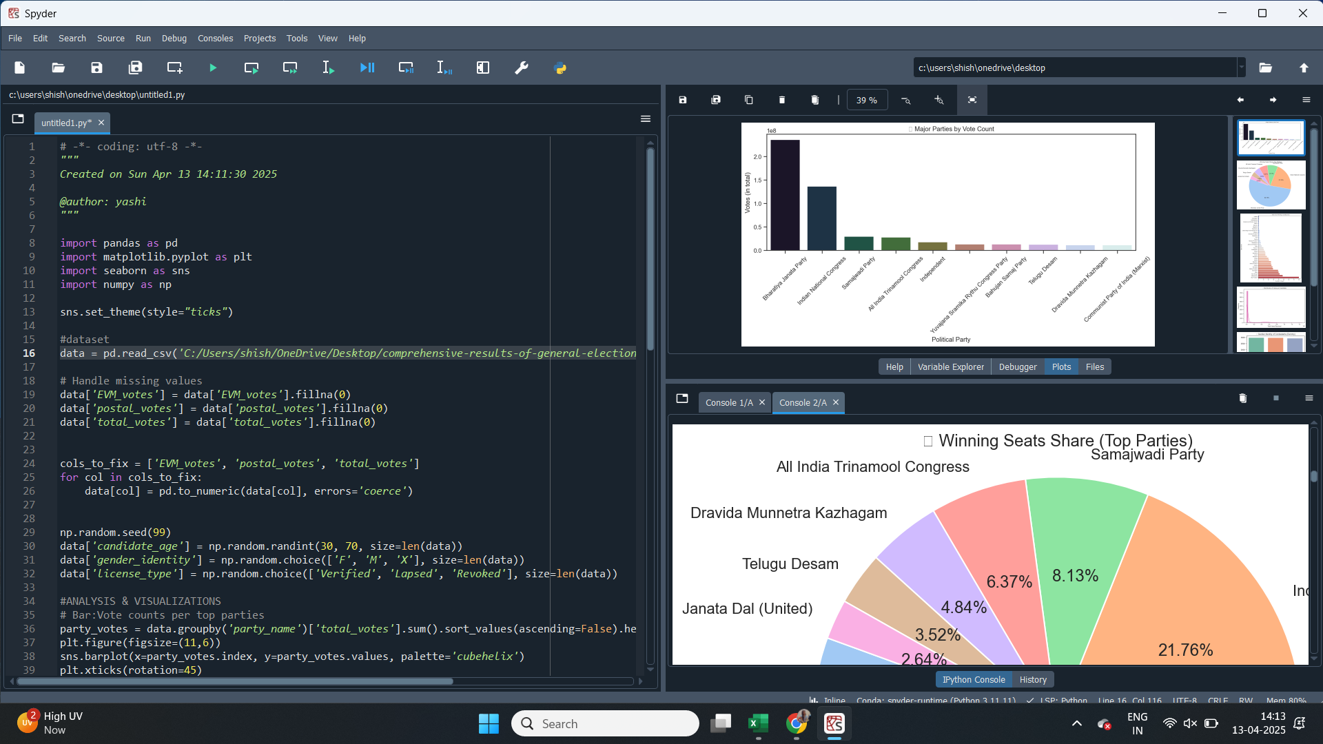

Column chart of votes given to different parties with BJP being on top and INC being second
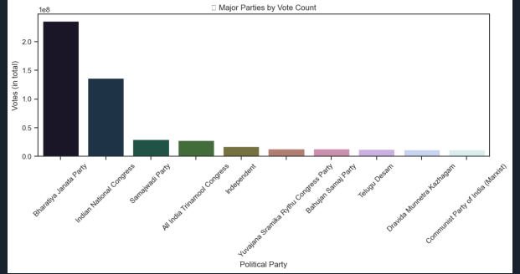

Pie chart of winning seats share
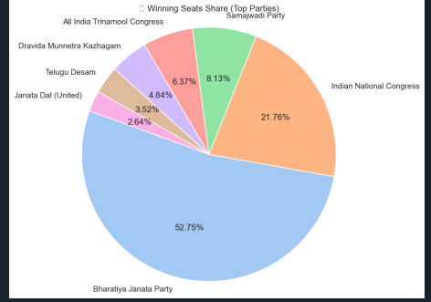

Bar chart of state wise winning constituencies with Uttar Pradesh, Maharashtra and West Bengal
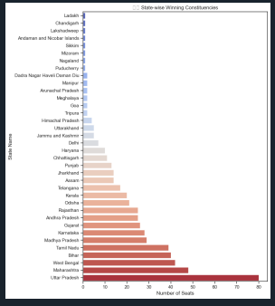

Histogram with KDE(kernel Density Estimation) of Distribution of votes per candidate
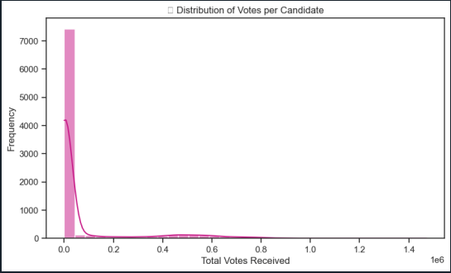

Count plot: Number of gender wise voters
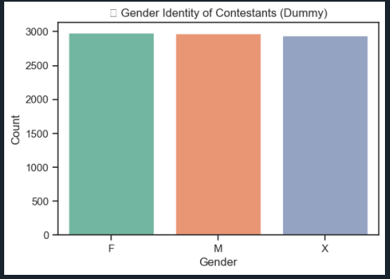

Correlation heatmap : relationship between

CHALLENGES FACED

Missing Values: Some vote columns had missing data that had to be carefully filled to avoid incorrect results.
No Demographic Data: The dataset lacked demographic fields like gender or age, so synthetic data was added using random generation.
Graph Selection: Picking the right visual representation for each pattern required experimentation with multiple chart types.
Balancing Clarity & Complexity: Ensuring the charts were easy to read while still being rich in insight was a design challenge.

ANALYSIS ON DATASET
- Specific Requirements:
The analysis is aimed to
Clean and preprocess data for accurate results
Identify the most successful political parties
Determine vote distribution and participation
Simulate demographics for deeper understanding
Provide clear and interactive visualizations
- Analysis Results
After performing preprocessing and exploratory data analysis, the following key results were derived:
Top Performing Parties:
Parties like BJP and INC received the highest total votes across most states.
State-wise Winning Trends:
Certain states like Uttar Pradesh and Maharashtra had the highest vote densities and played crucial roles in overall outcomes.
Vote Share Patterns:
Most winning candidates had a margin of over 10,000 votes, highlighting strong public support.